Assignment Day 3
Answer*
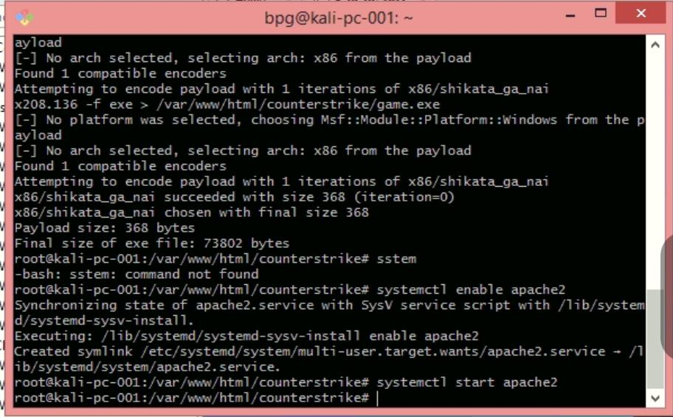
- I have created the paylaod for Windows using mfsvenom command, the created payload size as shown in the picture is 73802 bytes.
IP of Kali machine : 192.168.208.136/24

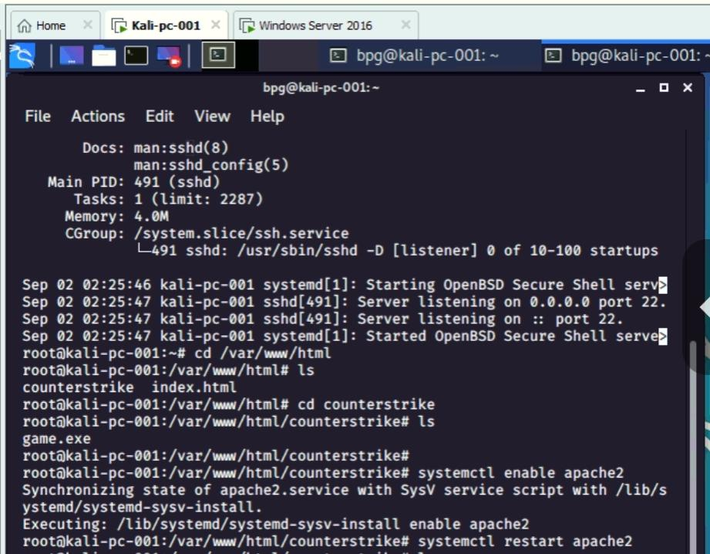
*Now enabling Apache2 in Kali
#Command – systemctl enable apache2
systemctl restart apache2
- Accessing The Payload Using Windows Machine
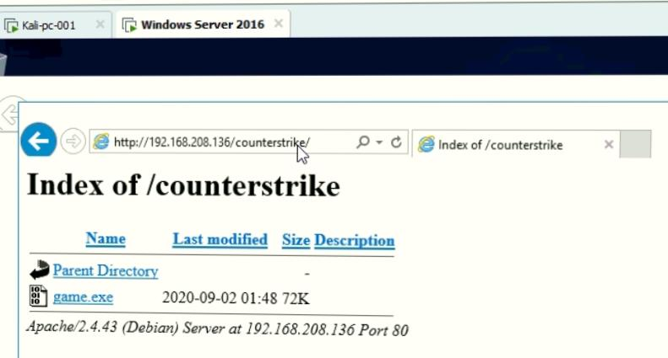
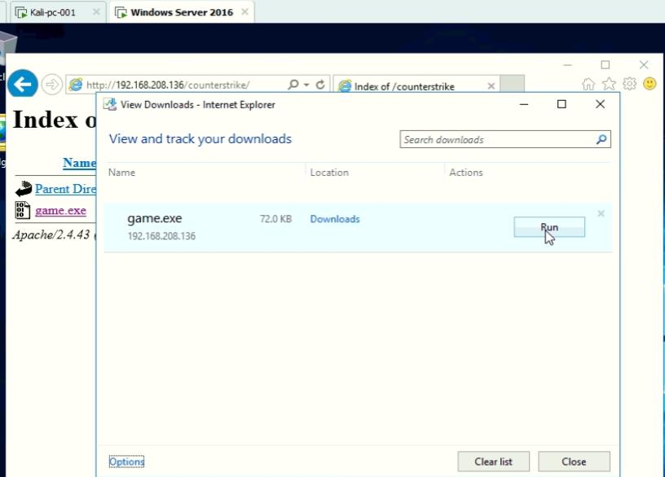
- Executing The Payload in Windows machine

- Now Opening The msfcosole and accessing the windows content
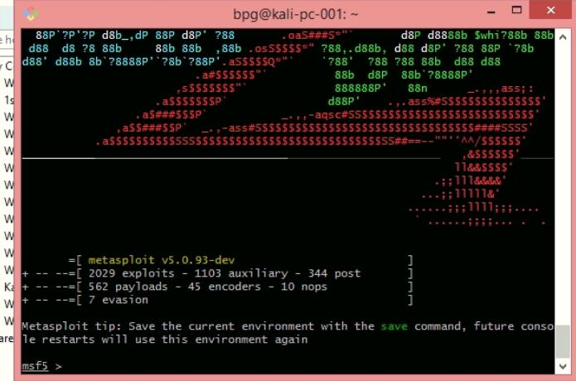
- Getting the Information from >sysinfo command
- Uploading a.txt file
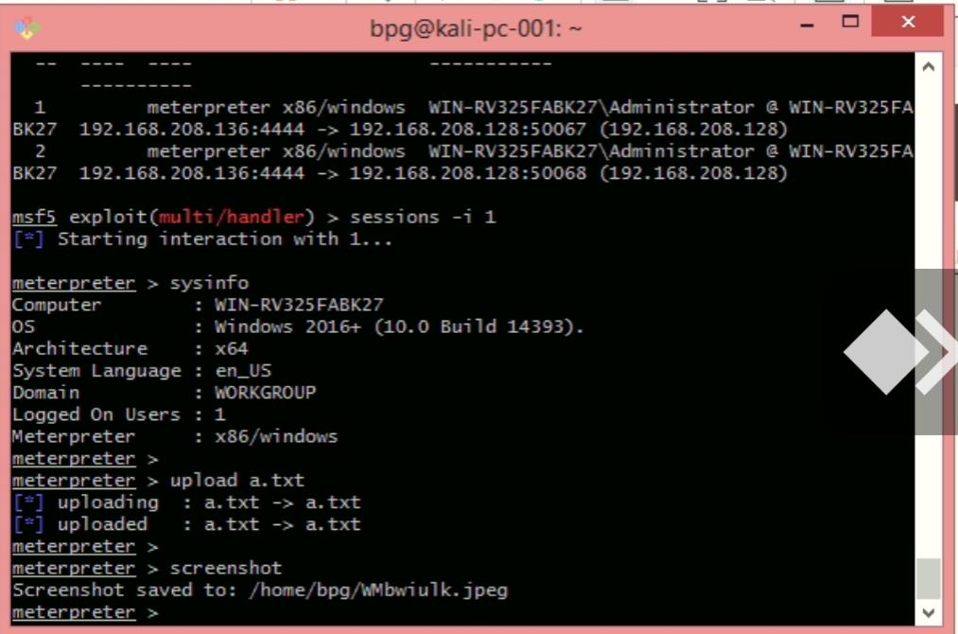
- Taking screenshot

